European Network of Paediatric Research at EMA elects new chair

Share

News 14/10/2019

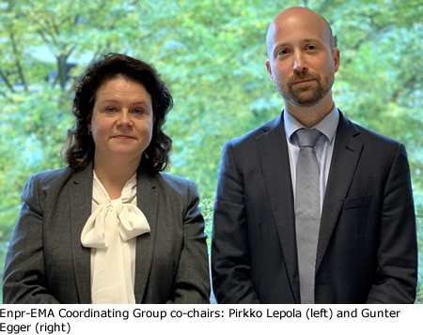The [European Network of Paediatric Research at the European Medicines Agency](https://www.ema.europa.eu/en/glossary/european-network-paediatric-research-european-medicines-agency) (Enpr-EMA) has elected Pirkko Lepola of the Finnish Investigators Network for Pediatric Medicines (FinPedMed) as the new chair of its Coordinating Group. Mrs Lepola will co-chair the [Enpr-EMA Coordinating Group](https://www.ema.europa.eu/en/documents/other/mandate-coordinating-group-european-network-paediatric-research-european-medicines-agency-enpr-ema_en.pdf" \t "_blank), together with Gunter Egger, scientific officer in EMA’s paediatric medicines office, for the next three years. The vote took place during the [annual meeting of the Enpr-EMA Coordinating Group in October 2019](https://www.ema.europa.eu/en/events/2019-annual-meeting-members-coordinating-group-european-network-paediatric-research-ema-enpr-ema).

Pirkko Lepola is the Executive Secretary of FinPedMed at the Department of Children and Adolescents of Helsinki University Central Hospital. She has strong expertise in paediatric [clinical trials](https://www.ema.europa.eu/en/glossary/clinical-trial), paediatric research ethics, trial management and drug development, and has been actively involved in various Enpr-EMA activities since 2010. Over the past few years, Mrs Lepola has led a number of initiatives and working groups to improve interaction between Enpr-EMA networks that had a real impact on the development of paediatric medicine development across Europe. She has been Enpr-EMA’s liaison with EUREC, the European network of Research Ethics Committees. She was one of the driving forces behind the establishment of the NordicPedMed, a network of investigators of paediatric medicines from the Nordic countries and co-created the concept of the first Nordic Conference on Paediatric Medicines.

“Enpr-EMA is a unique pan-European platform that facilitates information and knowledge sharing throughout all stages of the development of medicines for children,” said Pirkko Lepola. “As chair, I aim to strengthen the close collaboration between its current members and various existing and new initiatives around this topic. It is important to support new networks to develop and join Enpr-EMA; and further enhance interaction with multi-stakeholder groups and companies in the field of paediatric drug development in order to foster high-quality research on the safety and effectiveness of medicines for children.”

Pirkko Lepola replaces Mark Turner of the National Institute for Health Research Clinical Research Network-Children (NIHR CRN-Children) who is retiring as Enpr-EMA Coordinating Group Chair, having served the maximum of two three-year mandates.

Enpr-EMA is a network of research networks, investigators and centres with recognised expertise in performing clinical studies in children. It was established by EMA in 2008 to coordinate studies relating to paediatric [medicinal products](https://www.ema.europa.eu/en/glossary/medicinal-product), to avoid duplication of studies and testing in children, and to build the necessary scientific and administrative competences at European level in order to increase availability of medicines authorised for use in children.